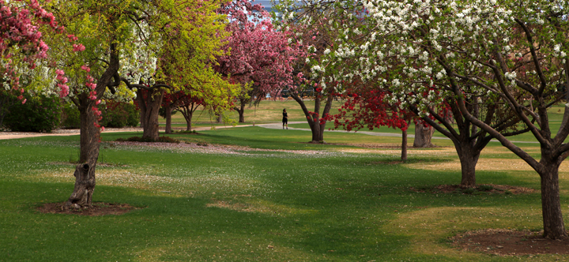
DENVER UNIT 361 - SPRING SECTIONAL
March 4-6, 2022

NOTE NEW LOCATION
Arapahoe County Fairgrounds, 25690 E. Quincy Ave, Aurora, CO 80016
*** Masks and Proof of Vaccination required ***
See Denverbridge.org for latest Covid protocols

FRIDAY, MARCH 4, 2022 lunch on your own
10:00 AM Beginner Pairs Single Session
10:00 AM & 3:00 PM Stratified Pairs Single Sessions
10:00 AM & 3:00 PM Bracketed Teams Double Session
10:00 AM & 3:00 PM Stratified Non-Life Master Single Sessions
(NLM) Pairs

SATURDAY, MARCH 5, 2022 lunch on your own
10:00 AM Beginner Pairs Single Session
10:00 AM & 3:00 PM Stratified Open Pairs 2 Session Event
10:00 AM & 3:00 PM Stratified Open Pairs Single Sessions
10:00 AM & 3:00 PM Stratified NLM Pairs Single Sessions

SUNDAY, MARCH 6, 2022 Lunch provided with team entry
10:00 AM Bracketed Teams Play Through

Beginner Pairs: 0-20 masterpoints. No player over 20 masterpoints.
NLM (Non-Life Master) Pairs: 0-500 masterpoints. No Life Masters. No player over 500 masterpoints.
Open Pair Stratification: A=2000+; B=750-2000; C=0-750. Pairs stratified by average masterpoints.
Bracketed Teams: Stratified by average masterpoints. Top three winners in each bracket
will receive overall awards. Teams play only teams in their bracket. Brackets may be handicapped.
Friday Teams: Balanced at Director’s discretion.
Sunday Teams: 7 rounds of 7 boards. Groups of 8 depending on attendance.

Tournament Chair: Sectional@DenverBridge.org
Partnerships: Partners@DenverBridge.org , request form: DenverBridge.org/partners
Tournament Director: tbd

Entry Fees: $12 per session for active ACBL/ABA members, $120 per Sunday team
Free play for ACBL members with 0-5 masterpoints. ACBL youth and junior (age 25 and under) discount.
Small additional fees for lapsed members. See our tournament pricing page or a tournament contact.

Denver Unit 361 Sanction Number 2203341
Scent free event – Please be considerate of your fellow players
NO ALCOHOL CONSUMPTION OR DRUGS ALLOWED

